TO Get to Auto Correct Options


Hit the Office Button

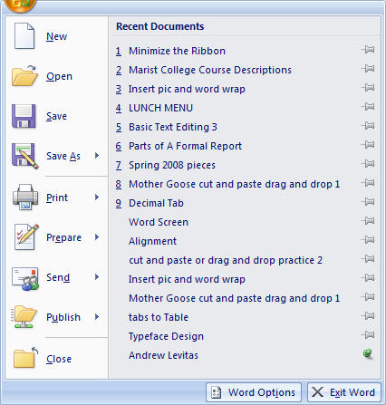

Click Word Options

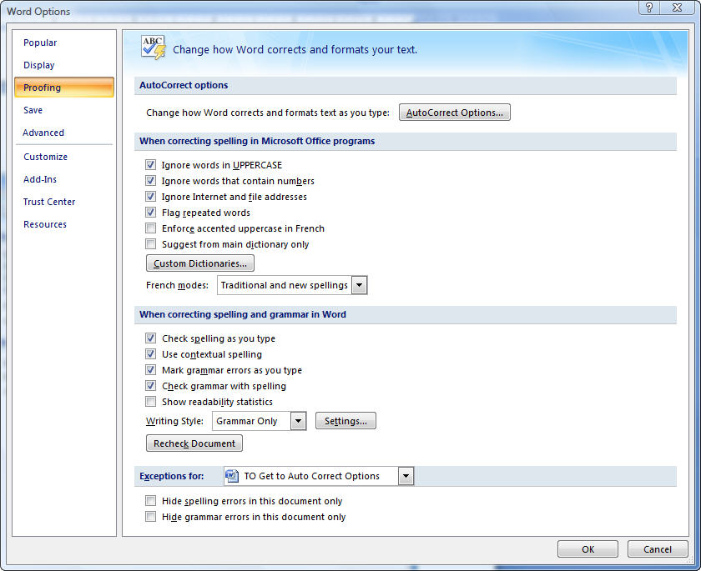
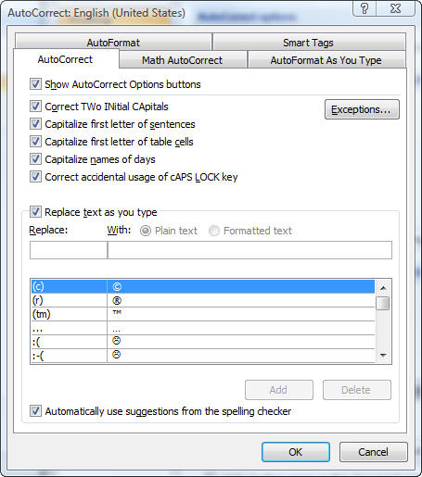
Click on Proofing.

Then On

Then:
_________________________________
_________________________________
_________________________________
_________________________________
_________________________________

