Headers / Footers

Insert a predefined header or footer
- On the Insert tab, in the Header & Footer group, click Header or Footer.
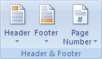
- Click the header or footer design that you want.
The header or footer is inserted on every page of the document.

Insert a custom header or footer
- On the Insert tab, in the Header & Footer group, click Header or Footer.
- Click Edit Header or Edit Footer.
- Type text or insert graphics and other content by using the options in the Insert group on the Design tab, under the Header & Footer Tools tab.
