Creating an Index
Creating an Index is tedious and time consuming. However, it is not actually hard to accomplish.
As I always recommend leave your formatting to after you type up your project
- Go to the References tab.
    - Select a word in your document
    - Click on
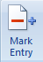
This Dialog Box will open
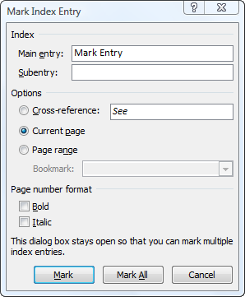
Click on Mark, then close

When you have marked all of your items click on Insert Index

