Create Table of Contents
Creating a Table of Contents is simpler than one might think. If you set up your formatting properly it is as easy as hitting a button.
- As I always recommend leave your formatting to after you type up your project
- Use Styles directly or use your format painter
    - Heading 1 and heading 2

- Once it’s all set to than you can create your table of contents
    - Go to the reference tab
    - Click on table of contents
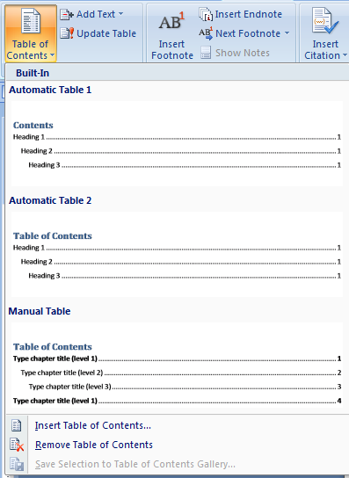
    - Pick an automatic table

You can Double click on any page number and it will take you to the heading.

